Table Structure for uMaterials and uMaterialVersions

table uMaterials
materialId varchar(255) not null
status int
currentVersionId varchar(255) not null
materialComments varchar(MAX) default 'NULL'
groupManagerApprovalEventId int
changeDate datetime
changedBy varchar(100)
reorderPoint int
reordered varchar(100) default 0
lastLocation varchar(max)
daysToExtendAutoOrderNeedByDate int default 0
reorderPointsComments varchar(max)
reorderPointsRoutingComments varchar(max)
prodAProcessingDays int default 1
prodBProcessingDays int default 0
qcProcessingDays int default 0
deliveryDays int default 0
minimumProcessingDays int default 1
oldestLotNotificationQTY int
oldestLotNotificationSent bit
oldestLot varchar(255)
eventId int
notes varchar(MAX)
linkToVendorWebsite varchar(MAX)
primary key (materialId, currentVersionId)

index uMaterialIndex on uMaterials (materialId, status, currentVersionId)
index uMaterialCurrentVersionIdIndex on uMaterials (currentVersionId)

table uMaterialVersions – Information around product version
materialVersionId varchar(255) not null
groupManagerApprovalEventId int
materialVersionComments varchar(max)
materialId varchar(255) not null
description varchar(255)
class varchar(30)
type int
lotCritical bit default 0 not null
qcFormNumber int
vendorMaterialNumber
vendorNumber
formulaWeight varchar(50)
unitLabeledByStoreroom varchar(15)
storageTemp varchar(15)
storageLocation varchar(2) default 'RL'
uomsch varchar(4) default 'EACH'
currencyId varchar(5) default 'Z-US$'
mfgUnitPrice float default 0
mfgUnit int default 1
mfgUom varchar(50)
mfgUnitsPerPurchaseUnit float
purchaseUnit float
purchaseUom varchar(50)
purchaseUnitPrice decimal(18, 2)
percentScrapRepeat int default 0 not null
rawMaterialFactor decimal(18, 5) default 1.12 not null
indirectFactor decimal(18, 5) default 1.75 not null
otherCostsDescription varchar(255)
otherCosts decimal(18, 2) default 0 not null
newItem bit default 1 not null
batchSizeNum int default 1
batchVolNum real default 0
batchVolUom varchar(50) default '?'
subUnitVol real default 0
subUnitUom varchar(50) default '?'
passageNumberRequired bit default 0
linkMadeDates bit default 0
rlUseOnly bit default 0
expNum int
expUom varchar(50)
ph varchar(20)
phTolerance varchar(20)
processingTime int default 5
productionTime int default 0
productionTimePartB int default 0
qcTime int default 0
deliveryTime int default 5
# 0=Reagents, 1=Cell Culture, 2=Micro, 3=Controls, 4=Kits, 5=Clean Room, 6=Specialty, 7=Reagents1, 8=Reagents2, 9=Reagents3, 10=General, 11=Unknown
area int default 0
changeDate smalldatetime
changedBy varchar(100)
reviewDate smalldatetime
reviewedBy varchar(100)
reference varchar(1000)
osmolarityNeeded bit default 0
allergen bit default 0
biohazard bit default 0
carcinogen bit default 0
caustic bit default 0
controlledSubstance bit default 0
corrosive bit default 0
explosive bit default 0
flammable bit default 0
harmful bit default 0
irritant bit default 0
mutagen bit default 0
notApplicable bit default 0
neurotoxin bit default 0
notTested bit default 0
oxidizer bit default 0
poison bit default 0
radioactive bit default 0
reactive bit default 0
teratogen bit default 0
toxic bit default 0
filtered bit default 0
autoclaved bit default 0
sterile bit default 0
formPlan varchar(max)
formParts varchar(max)
mfgUnitPriceTemp float default 0
purchaseUnitPriceTemp decimal(18, 2) default 0 not null
percentScrapRepeatTemp int default 0 not null
rawMaterialFactorTemp decimal(18, 5) default 1.12 not null
indirectFactorTemp decimal(18, 5) default 1.75 not null
otherCostsDescriptionTemp varchar(255)
otherCostsTemp decimal(18, 2) default 0 not null
processingTimeTemp int default 5
productionTimeTemp int default 0
productionTimePartBTemp int default 0
qcTimeTemp int default 0
deliveryTimeTemp int default 5
lastUpdateEventId int
gpDescription varchar(255)
ghsHazardous varchar(50) default 'NULL'
controlledSubstanceSchedule varchar(10) default 'N/A'
concentration varchar(255) default 'NULL'
signalWord varchar(50) default 'NULL'
hazardStatement varchar(MAX) default 'NULL'
precautionaryStatement varchar(MAX) default 'NULL'
productContains varchar(MAX) default 'NULL'
pictograms varchar(MAX) default 'NULL'
safetyErrorMessage varchar(MAX) default 'NULL'
#physicalState: 0= N/A; 1=Liquid (default); 2=Solid; 3=Kit
physicalState int default 'NULL'
eventId int
notes varchar(max)
qcOnly bit default 0 not null
purchaseUnitPriceForNextFY decimal(18, 2)
commonDescription varchar(255)
hygroscopic bit default 0

index PK_uMaterialVersionsIndex ON uMaterialVersions (materialId,materialVersionId desc)
# The next index may need to be setup by hand as a non-clustered index
index IX_uMaterialVersions ON uMaterialVersions (materialVersionId,materialId)
index IX_uMaterialVersions_1 ON uMaterialVersions (type, materialId, materialVersionId, purchaseUnitPrice, indirectFactor, batchSizeNum, purchaseUnitPriceTemp, indirectFactorTemp)
INDEX [IX_uMaterialVersions_matverIdBatchSizeBatchVol] ON [UNIFLOW].[uMaterialVersions] ( [materialVersionId] ASC ) INCLUDE([batchSizeNum],[batchVolNum]) WITH (ONLINE=ON, DATA_COMPRESSION=PAGE) ON [PRIMARY]

5 Manufacturing Instructions
- N-13200-6 -- NSE Muscles Phosphate Buffer
- KT-0905-5 -- Ethanol, 100%
- V-10026-7 -- 2-Propanol, 100%
- A-09000-1 -- Acetonitrile, 200mL
- E-81000-14 -- EMEM 2X
N-13200-6 -- NSE Muscles Phosphate Buffer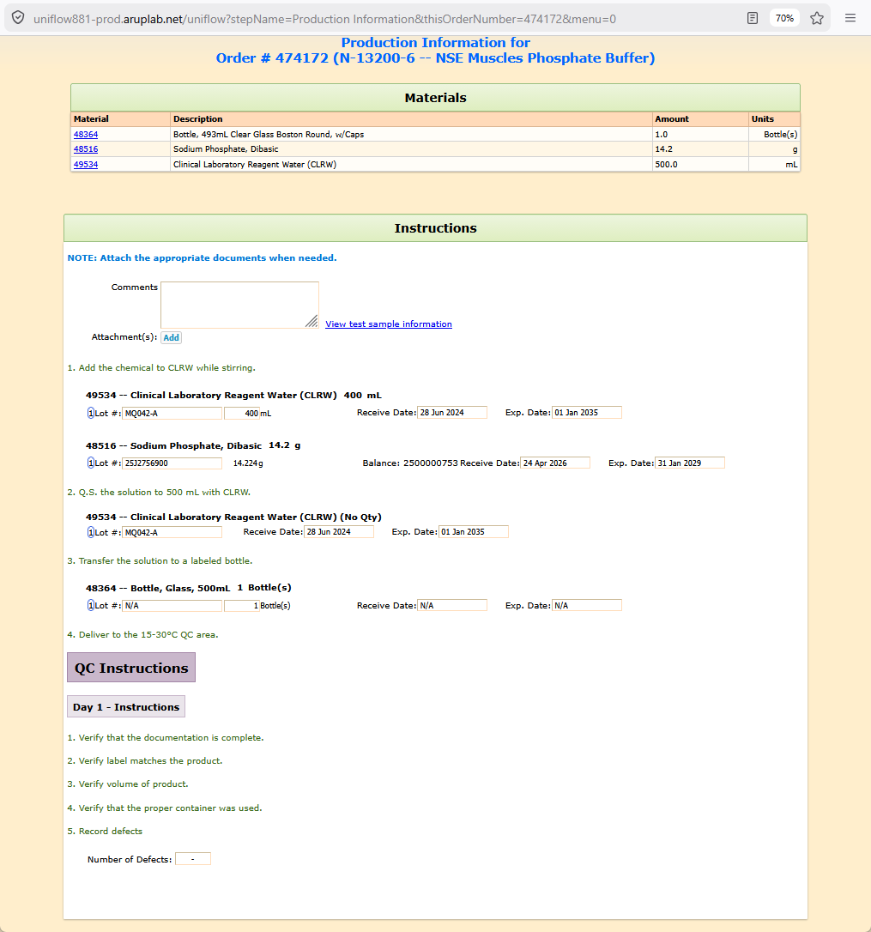
FormPlan for N-13200-6 -- NSE Muscles Phosphate Buffer
formPartValues
part formParts_text_0
parameter formParts_instructions_0
value= <b><span style='color:rgb(0,120,215);'>NOTE: Attach the appropriate documents when needed.</span></b>
part formParts_attachments_1
parameter formParts_Add_1
value= Add
part formParts_text_2
parameter formParts_instructions_2
value= 1. Add the chemical to CLRW while stirring.
part formParts_materialNotWeighed_3
parameter formParts_selectedItem_3
value= 49534 -- Clinical Laboratory Reagent Water (CLRW)
parameter formParts_reqAmount_3
value= 400
parameter formParts_reqAmountUnits_3
value= mL
parameter formParts_reqItem_3
value= 49534
parameter formParts_usedAmountUnits_3
value= mL
part formParts_materialWeighed_4
parameter formParts_selectedItem_4
value= 48516 -- Sodium Phosphate, Dibasic
parameter formParts_reqAmount_4
value= 14.2
parameter formParts_reqAmountUnits_4
value= g
parameter formParts_getWeightButton_4
value= Get weight
parameter formParts_reqItem_4
value= 48516
parameter formParts_usedAmountUnits_4
value= g
part formParts_text_5
parameter formParts_instructions_5
value= 2. Q.S. the solution to 500 mL with CLRW.
part formParts_materialNoQty_6
parameter formParts_selectedItem_6
value= 49534 -- Clinical Laboratory Reagent Water (CLRW)
parameter formParts_reqItem_6
value= 49534
part formParts_text_7
parameter formParts_instructions_7
value= 3. Transfer the solution to a labeled bottle.
part formParts_materialNotWeighed_8
parameter formParts_selectedItem_8
value= 48364 -- Bottle, Glass, 500mL
parameter formParts_reqAmount_8
value= 1
parameter formParts_reqAmountUnits_8
value= Bottle(s)
parameter formParts_reqItem_8
value= 48364
parameter formParts_usedAmountUnits_8
value= Bottle(s)
part formParts_text_9
parameter formParts_instructions_9
value= 4. Deliver to the 15-30°C QC area.
part formParts_separator_10
part formParts_separatorDay1_11
part formParts_text_12
parameter formParts_instructions_12
value= 1. Verify that the documentation is complete.
part formParts_text_13
parameter formParts_instructions_13
value= 2. Verify label matches the product.
part formParts_text_14
parameter formParts_instructions_14
value= 3. Verify volume of product.
part formParts_text_15
parameter formParts_instructions_15
value= 4. Verify that the proper container was used.
part formParts_text_16
parameter formParts_instructions_16
value= 5. Record defects
part formParts_defectRate_17
KT-0905-5 -- Ethanol, 100%
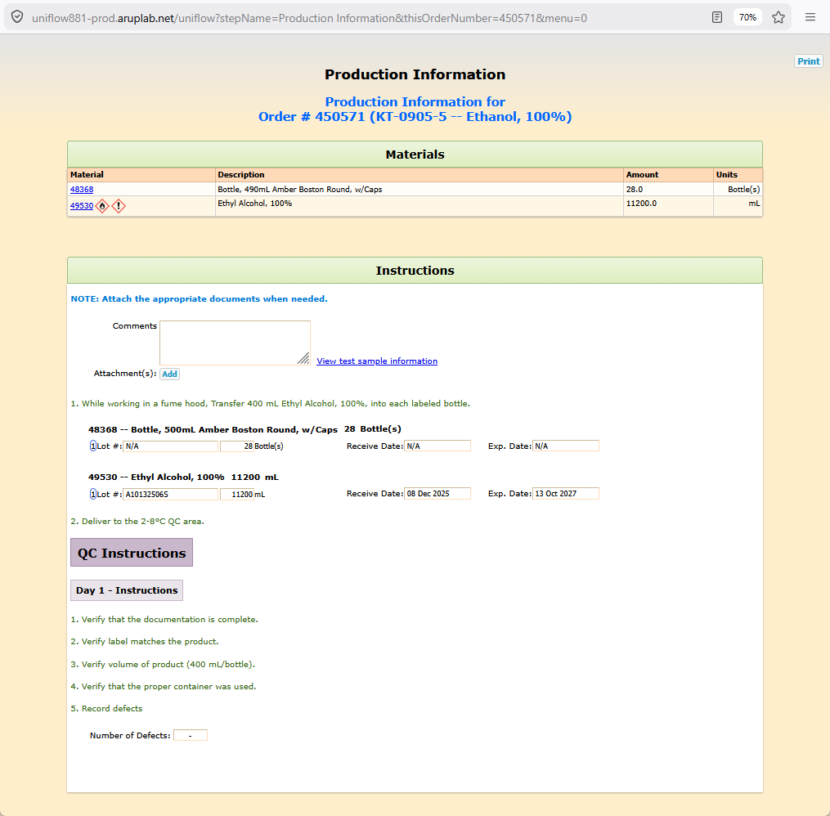
FormPlan for KT-0905-5 -- Ethanol, 100%
formPartValues
part formParts_text_0
parameter formParts_instructions_0
value= <b><span style='color:rgb(0,120,215);'>NOTE: Attach the appropriate documents when needed.</span></b>
part formParts_attachments_1
parameter formParts_Add_1
value= Add
part formParts_text_2
parameter formParts_instructions_2
value= 1. While working in a fume hood, Transfer 400 mL Ethyl Alcohol, 100%, into each labeled bottle.
part formParts_materialNotWeighed_3
parameter formParts_selectedItem_3
value= 48368 -- Bottle, 500mL Amber Boston Round, w/Caps
parameter formParts_reqAmount_3
value= 28
parameter formParts_reqAmountUnits_3
value= Bottle(s)
parameter formParts_reqItem_3
value= 48368
parameter formParts_usedAmountUnits_3
value= Bottle(s)
part formParts_materialNotWeighed_4
parameter formParts_selectedItem_4
value= 49530 -- Ethyl Alcohol, 100%
parameter formParts_reqAmount_4
value= 11200
parameter formParts_reqAmountUnits_4
value= mL
parameter formParts_reqItem_4
value= 49530
parameter formParts_usedAmountUnits_4
value= mL
part formParts_text_5
parameter formParts_instructions_5
value= 2. Deliver to the 2-8°C QC area.
part formParts_separator_6
part formParts_separatorDay1_7
part formParts_text_8
parameter formParts_instructions_8
value= 1. Verify that the documentation is complete.
part formParts_text_9
parameter formParts_instructions_9
value= 2. Verify label matches the product.
part formParts_text_10
parameter formParts_instructions_10
value= 3. Verify volume of product (400 mL/bottle).
part formParts_text_11
parameter formParts_instructions_11
value= 4. Verify that the proper container was used.
part formParts_text_12
parameter formParts_instructions_12
value= 5. Record defects
part formParts_defectRate_13

V-10026-7 -- 2-Propanol, 100%
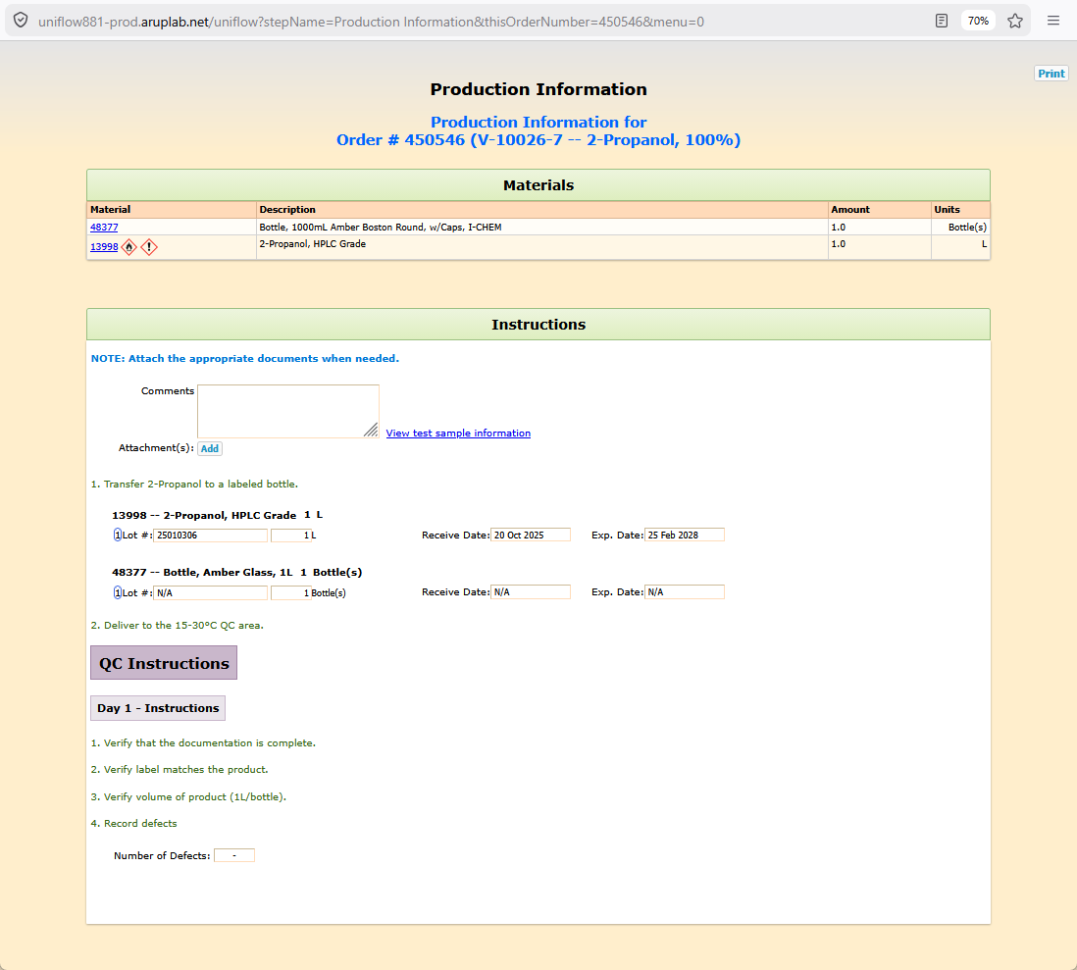
FormPlan for V-10026-7 -- 2-Propanol, 100%
formPartValues
part formParts_text_0
parameter formParts_instructions_0
value= <b><span style='color:rgb(0,120,215);'>NOTE: Attach the appropriate documents when needed.</span></b>
part formParts_attachments_1
parameter formParts_Add_1
value= Add
part formParts_text_2
parameter formParts_instructions_2
value= 1. Transfer 2-Propanol to a labeled bottle.
part formParts_materialNotWeighed_3
parameter formParts_selectedItem_3
value= 13998 -- 2-Propanol, HPLC Grade
parameter formParts_reqAmount_3
value= 1
parameter formParts_reqAmountUnits_3
value= L
parameter formParts_reqItem_3
value= 13998
parameter formParts_usedAmountUnits_3
value= L
part formParts_materialNotWeighed_4
parameter formParts_selectedItem_4
value= 48377 -- Bottle, Amber Glass, 1L
parameter formParts_reqAmount_4
value= 1
parameter formParts_reqAmountUnits_4
value= Bottle(s)
parameter formParts_reqItem_4
value= 48377
parameter formParts_usedAmountUnits_4
value= Bottle(s)
part formParts_text_5
parameter formParts_instructions_5
value= 2. Deliver to the 15-30°C QC area.
part formParts_separator_6
part formParts_separatorDay1_7
part formParts_text_8
parameter formParts_instructions_8
value= 1. Verify that the documentation is complete.
part formParts_text_9
parameter formParts_instructions_9
value= 2. Verify label matches the product.
part formParts_text_10
parameter formParts_instructions_10
value= 3. Verify volume of product (1L/bottle).
part formParts_text_11
parameter formParts_instructions_11
value= 4. Record defects
part formParts_defectRate_12

A-09000-1 -- Acetonitrile, 200mL
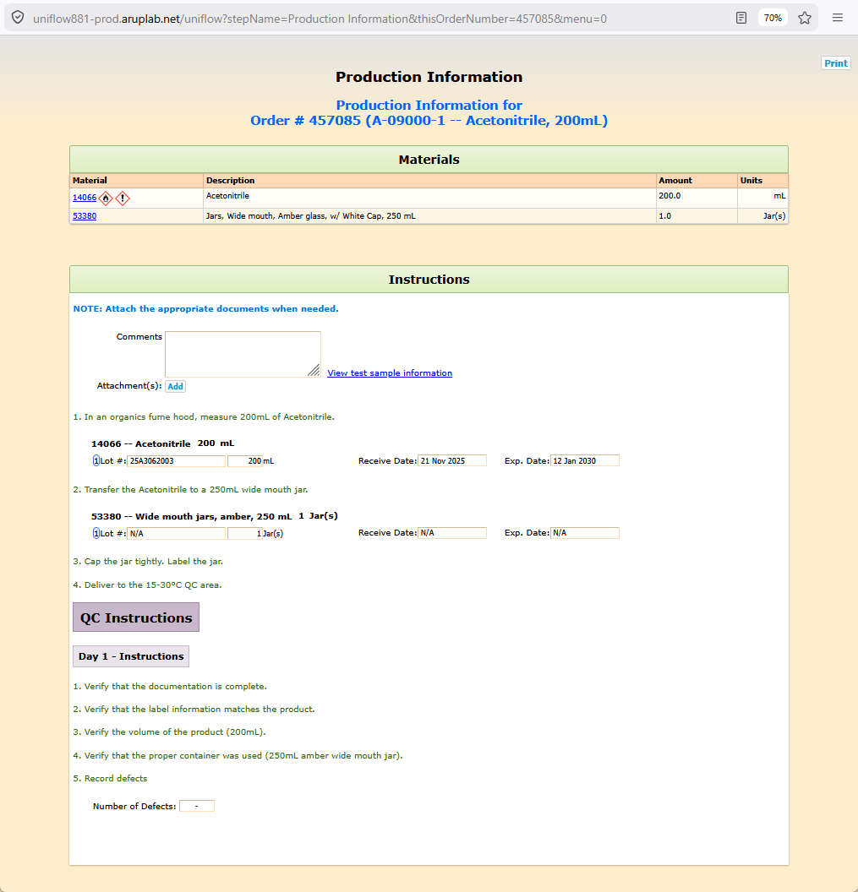
FormPlan for A-09000-1 -- Acetonitrile, 200mL
formPartValues
part formParts_text_0
parameter formParts_instructions_0
value= <b><span style='color:rgb(0,120,215);'>NOTE: Attach the appropriate documents when needed.</span></b>
part formParts_attachments_1
parameter formParts_Add_1
value= Add
part formParts_text_2
parameter formParts_instructions_2
value= 1. In an organics fume hood, measure 200mL of Acetonitrile.
part formParts_materialNotWeighed_3
parameter formParts_selectedItem_3
value= 14066 -- Acetonitrile
parameter formParts_reqAmount_3
value= 200
parameter formParts_reqAmountUnits_3
value= mL
parameter formParts_reqItem_3
value= 14066
parameter formParts_usedAmountUnits_3
value= mL
part formParts_text_4
parameter formParts_instructions_4
value= 2. Transfer the Acetonitrile to a 250mL wide mouth jar.
part formParts_materialNotWeighed_5
parameter formParts_selectedItem_5
value= 53380 -- Wide mouth jars, amber, 250 mL
parameter formParts_reqAmount_5
value= 1
parameter formParts_reqAmountUnits_5
value= Jar(s)
parameter formParts_reqItem_5
value= 53380
parameter formParts_usedAmountUnits_5
value= Jar(s)
part formParts_text_6
parameter formParts_instructions_6
value= 3. Cap the jar tightly. Label the jar.
part formParts_text_7
parameter formParts_instructions_7
value= 4. Deliver to the 15-30°C QC area.
part formParts_separator_8
part formParts_separatorDay1_9
part formParts_text_10
parameter formParts_instructions_10
value= 1. Verify that the documentation is complete.
part formParts_text_11
parameter formParts_instructions_11
value= 2. Verify that the label information matches the product.
part formParts_text_12
parameter formParts_instructions_12
value= 3. Verify the volume of the product (200mL).
part formParts_text_13
parameter formParts_instructions_13
value= 4. Verify that the proper container was used (250mL amber wide mouth jar).
part formParts_text_14
parameter formParts_instructions_14
value= 5. Record defects
part formParts_defectRate_15

E-81000-14 -- EMEM 2X
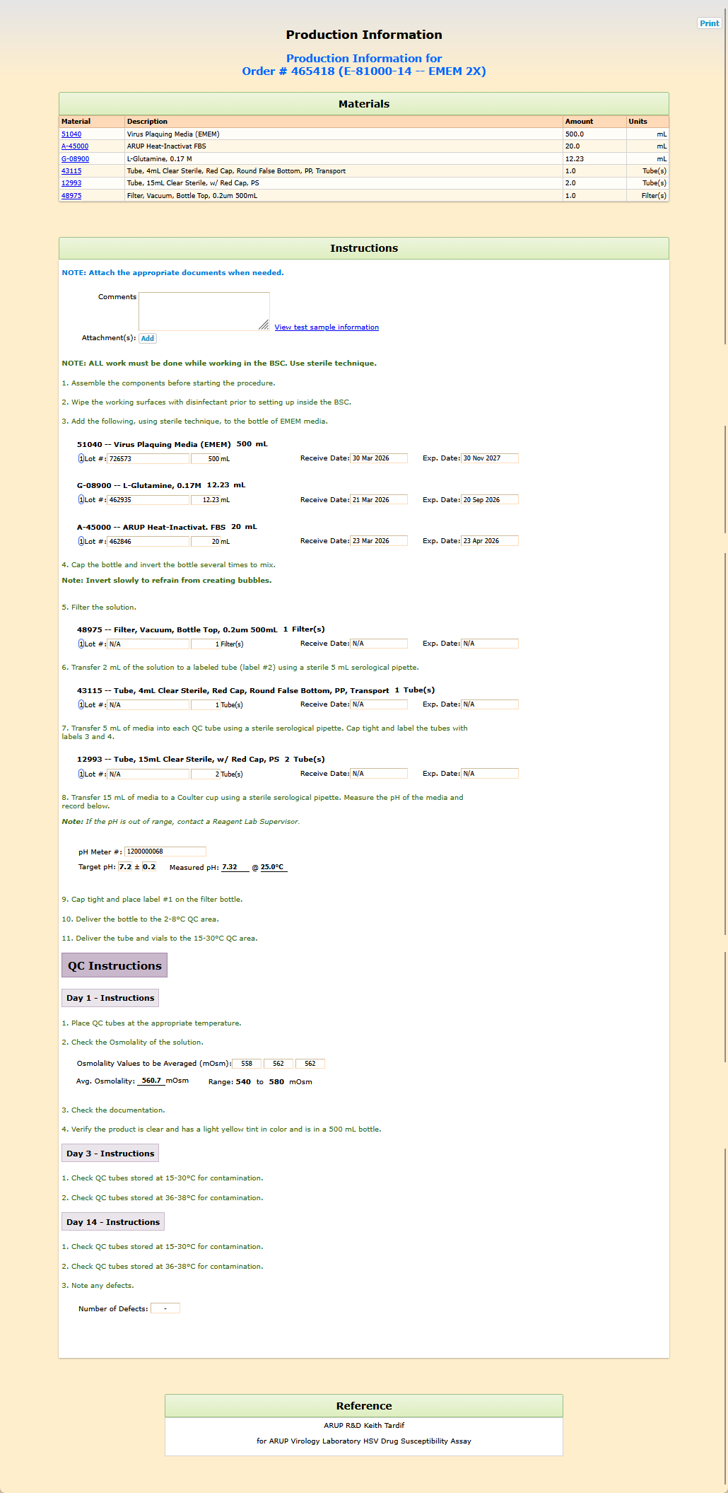
FormPlan for E-81000-14 -- EMEM 2X
formPartValues
part formParts_text_0
parameter formParts_instructions_0
value= <b><span style='color:rgb(0,120,215);'>NOTE: Attach the appropriate documents when needed.</span></b>
part formParts_attachments_1
parameter formParts_Add_1
value= Add
part formParts_text_2
parameter formParts_instructions_2
value= <b>NOTE: ALL work must be done while working in the BSC. Use sterile technique.</b>
part formParts_text_3
parameter formParts_instructions_3
value= 1. Assemble the components before starting the procedure.
part formParts_text_4
parameter formParts_instructions_4
value= 2. Wipe the working surfaces with disinfectant prior to setting up inside the BSC.
part formParts_text_5
parameter formParts_instructions_5
value= 3. Add the following, using sterile technique, to the bottle of EMEM media.
part formParts_materialNotWeighed_6
parameter formParts_selectedItem_6
value= 51040 -- Virus Plaquing Media (EMEM)
parameter formParts_reqAmount_6
value= 500
parameter formParts_reqAmountUnits_6
value= mL
parameter formParts_reqItem_6
value= 51040
parameter formParts_usedAmountUnits_6
value= mL
part formParts_materialNotWeighed_7
parameter formParts_selectedItem_7
value= G-08900 -- L-Glutamine, 0.17M
parameter formParts_reqAmount_7
value= 12.23
parameter formParts_reqAmountUnits_7
value= mL
parameter formParts_reqItem_7
value= G-08900
parameter formParts_usedAmountUnits_7
value= mL
part formParts_materialNotWeighed_8
parameter formParts_selectedItem_8
value= A-45000 -- ARUP Heat-Inactivat. FBS
parameter formParts_reqAmount_8
value= 20
parameter formParts_reqAmountUnits_8
value= mL
parameter formParts_reqItem_8
value= A-45000
parameter formParts_usedAmountUnits_8
value= mL
part formParts_text_9
parameter formParts_instructions_9
value= 4. Cap the bottle and invert the bottle several times to mix.
- <b>Note: Invert slowly to refrain from creating bubbles.</b>
part formParts_text_10
parameter formParts_instructions_10
value= 5. Filter the solution.
part formParts_materialNotWeighed_11
parameter formParts_selectedItem_11
value= 48975 -- Filter, Vacuum, Bottle Top, 0.2um 500mL
parameter formParts_reqAmount_11
value= 1
parameter formParts_reqAmountUnits_11
value= Filter(s)
parameter formParts_reqItem_11
value= 48975
parameter formParts_usedAmountUnits_11
value= Filter(s)
part formParts_text_12
parameter formParts_instructions_12
value= 6. Transfer 2 mL of the solution to a labeled tube (label #2) using a sterile 5 mL serological pipette.
part formParts_materialNotWeighed_13
parameter formParts_selectedItem_13
value= 43115 -- Tube, 4mL Clear Sterile, Red Cap, Round False Bottom, PP, Transport
parameter formParts_reqAmount_13
value= 1
parameter formParts_reqAmountUnits_13
value= Tube(s)
parameter formParts_reqItem_13
value= 43115
parameter formParts_usedAmountUnits_13
value= Tube(s)
part formParts_text_14
parameter formParts_instructions_14
value= 7. Transfer 5 mL of media into each QC tube using a sterile serological pipette. Cap tight and label the tubes with labels 3 and 4.
part formParts_materialNotWeighed_15
parameter formParts_selectedItem_15
value= 12993 -- Tube, 15mL Clear Sterile, w/ Red Cap, PS
parameter formParts_reqAmount_15
value= 2
parameter formParts_reqAmountUnits_15
value= Tube(s)
parameter formParts_reqItem_15
value= 12993
parameter formParts_usedAmountUnits_15
value= Tube(s)
part formParts_text_16
parameter formParts_instructions_16
value= 8. Transfer 15 mL of media to a Coulter cup using a sterile serological pipette. Measure the pH of the media and record below.
- <i><b>Note:</b> If the pH is out of range, contact a Reagent Lab Supervisor.</i>
part formParts_pHMeter_17
parameter formParts_getPHButton_17
value= Get pH
parameter formParts_reqPH_17
value= 7.2
parameter formParts_reqPHRange_17
value= 0.2
part formParts_text_18
parameter formParts_instructions_18
value= 9. Cap tight and place label #1 on the filter bottle.
part formParts_text_19
parameter formParts_instructions_19
value= 10. Deliver the bottle to the 2-8°C QC area.
part formParts_text_20
parameter formParts_instructions_20
value= 11. Deliver the tube and vials to the 15-30°C QC area.
part formParts_separator_21
part formParts_separatorDay1_22
part formParts_text_23
parameter formParts_instructions_23
value= 1. Place QC tubes at the appropriate temperature.
part formParts_text_24
parameter formParts_instructions_24
value= 2. Check the Osmolality of the solution.
part formParts_osmolarity_25
parameter formParts_osmolarityLowerRangeValue_25
value= 540
parameter formParts_osmolarityUpperRangeValue_25
value= 580
part formParts_text_26
parameter formParts_instructions_26
value= 3. Check the documentation.
part formParts_text_27
parameter formParts_instructions_27
value= 4. Verify the product is clear and has a light yellow tint in color and is in a 500 mL bottle.
part formParts_separatorDay3_28
part formParts_text_29
parameter formParts_instructions_29
value= 1. Check QC tubes stored at 15-30°C for contamination.
part formParts_text_30
parameter formParts_instructions_30
value= 2. Check QC tubes stored at 36-38°C for contamination.
part formParts_separatorDay14_31
part formParts_text_32
parameter formParts_instructions_32
value= 1. Check QC tubes stored at 15-30°C for contamination.
part formParts_text_33
parameter formParts_instructions_33
value= 2. Check QC tubes stored at 36-38°C for contamination.
part formParts_text_34
parameter formParts_instructions_34
value= 3. Note any defects.
part formParts_defectRate_35

